H.T No
Regulations:
A19

Sreenidhi Institute of Science and Technology
(An Autonomous Institution)
Code No: 7M102 Date: 09-Oct-2020 (FN)

M.Tech I-Year I-Semester External Examination, October - 2020 (Supplementary)
ADVANCED FLUID DYNAMICS (TE)

Time: 2 Hours Max.Marks:70

Note: a) No additional answer sheets will be provided.
b) All sub-parts of a question must be answered at one place only, otherwise it will not be valued.
c) Missing data can be assumed suitably.

ANSWER ANY 5 OUT OF 8 QUESTIONS. EACH QUESTION CARRIES 14 MARKS.

1. | a) | 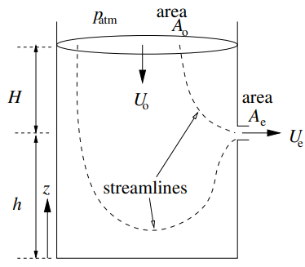  A tank of uniform cross section A0 has a small hole, with area Ae, and at a height h above the base, see Fig. The height of the fluid above the hole is H. What is the flow speed out of the drain ? | [7M]
 | b) | Derive Bernoulli's equation for steady flow. | [7M]
2. | a) | What are the differences between plane Couette and plane Poiseuille flow? | [7M]
 | b) | Derive the Navier stoke Equation for viscous compressible flow. | [7M]
3. | a) | What is boundary layer approximation? Explain briefly. | [7M]
 | b) | A volcano has erupted, spewing stones, steam, and ash several thousand feet into the atmosphere. After some time, the particles begin to settle to the ground. Consider a nearly spherical ash particle of diameter 50 mm, falling in air whose temperature is -50°C and whose pressure is 55 kPa. The density of the particle is 1240 kg/m³. Estimate the terminal velocity of this particle at this altitude. | [7M]
4. | a) | Water at 20⁰C (ρ = 998 kg/m³, and ν = 1 x 10⁻⁶ m²/s flows through a horizontal pipe of D = 0.1 m diameter with a flow rate of q = 4 x 10⁻² m³/s and a pressure gradient of ∆p/l = 2.59kPa/m. Determine the approximate thickness of the viscous sub layer and Darcy friction coefficient f. | [7M]
 | b) | For turbulent flow in pipes (smooth as well as rough) show that  (υmax/V)= 1.33√f +1 | [7M]
5. | a) | Explain the flow of compressible fluid in Convergent-Divergent passages. | [7M]
 | b) | Explain the measurement of discharge and velocity for compressible fluid flow. | [7M]
6. | a) | Air enters a pipe with pressure of 3 bar and temperature of 27ºC at Mach number of M = 0.25. Due to internal combustion heat was released and the exit temperature was found to be 127ºC. Calculate the exit Mach number, the exit pressure, the total exit pressure, and heat released and transferred to the air. At what amount of energy the exit temperature will start to decrease? Assume C_{P} = 1.004 (kJ/kgºC) | [7M]
 | b) | Air with Mach 3 enters a frictionless duct with heating. What is the maximum heat that can be added so that there is no subsonic flow? If a shock occurs immediately at the entrance, what is the maximum heat that can be added? | [7M]
7. | a) | Find the pressure field in the inviscid, incompressible flow with velocity field  u = (nx, −ny, 0). | [7M]
 | b) | Mean point velocities measured with the help of a pitot tube at mid-point and quarter point of a 0.2m diameter pipe were found to be 1.50 m/s and 1.35m/s respectively. If the flow in the pipe is turbulent, determine the discharge, friction factor and average height of roughness projections. | [7M]
8. | a) | To what change in pressure a liquid of specific gravity 1.2 should be subjected to cause reduction in volume by one percent? The velocity of sound in the liquid is 1500m/s | [10M]
 | b) | What is the fundamental concept of turbulence? Explain. | [4M]

-- 00 -- 00 –

